

|  |  |
| --- | --- |
| Employee Name: | MANOJ KUMAR YEKOLLU |
| Training Supervised by: | **KRISHNA BODDULURI** |
| Training Task #: | **ASSIGNMENT01012020** |
| Training Resource Materials: | **Spring Boot Scheduler and logs demo using inbuild H2 database.** |
| Training Task Date: | **01/01/2020** |
| Task Due Date: | **01/15/2020** |
| Task Submitted Date: | **01/15/2020** |
| Github link: |  |
| Technologies used for Training | **Spring boot, maven, java, Logger, LoggerFactory** |

**Task Description/Requirement:**

**Develop an Application using Spring to demonstrate the Scheduling mechanism and logs, to develop use the spring boot in built H2 Database.**

**High Level Synopsis:**

**Steps followed:**

1. Created a Started Spring application using Spring Initializer
2. Created separate packages for Model, DAO, Service
3. Added @EnableScheduler in Application.java to enable the scheduler for the application
4. created the User Model with Id and Name as parameters.
5. Created the Dao interface which extends the Jpa repository of user
6. Created UserService class to write the business logic.

Every 5 seconds : add an user to the DB

Every 15 Seconds: Fetch the users From the DB.

Used

@Scheduled(fixedRate=5000)

@Scheduled(cron="0/15 * * * * *" )

For set the 5 seconds wait time and 15 seconds corn time.

And finally @EnableScheduler enables these triggers.

**Output:**

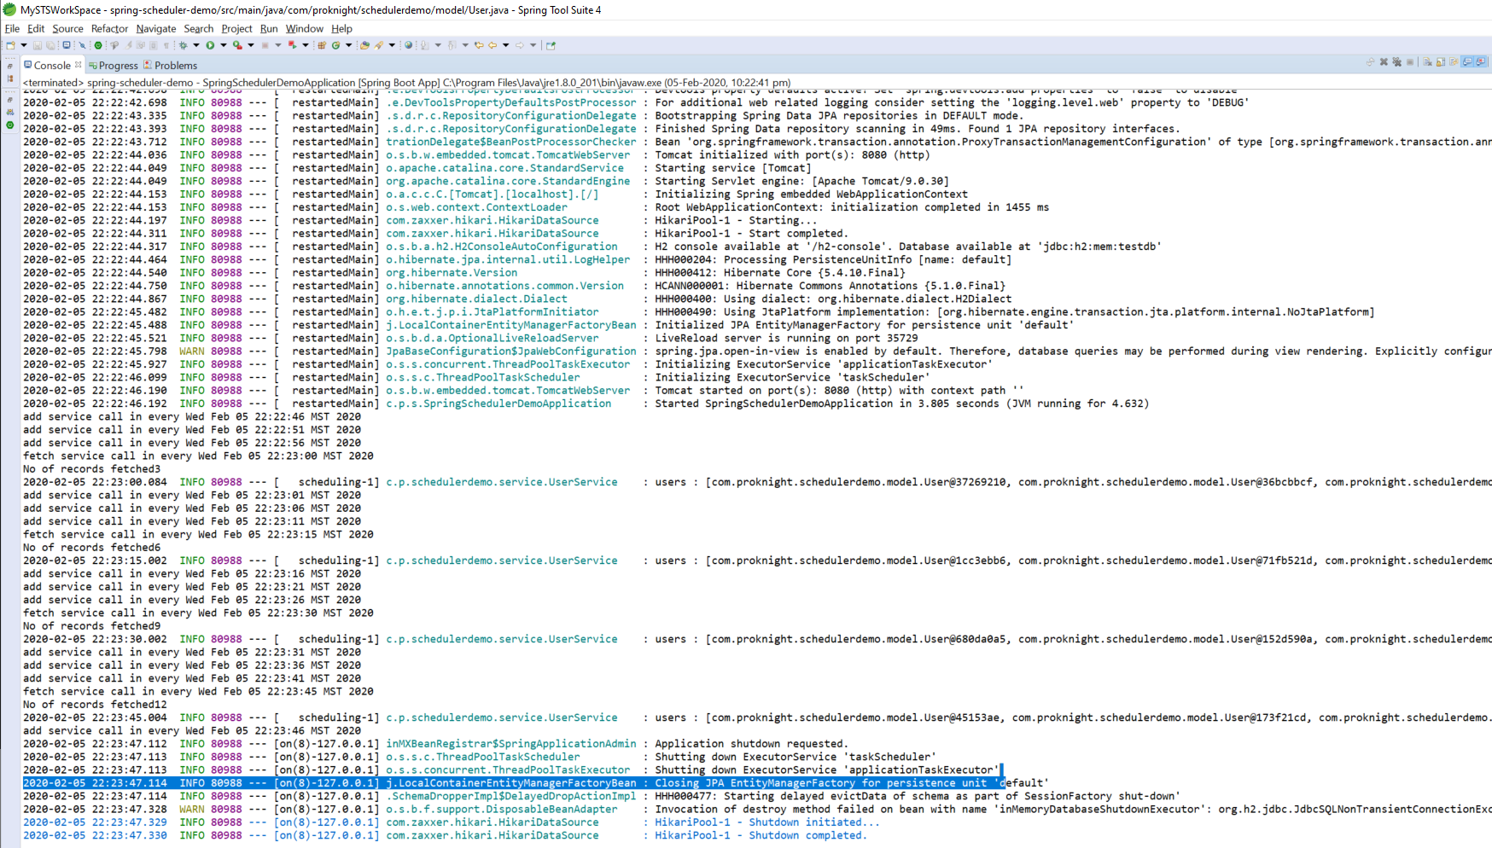

**I acknowledge that this document can be supplied to USCIS in compliance with CPT/OPT/STEM OPT audit:**

**Manoj Kumar Yekollu.**